***~~FINAL REPORT:~~***

**Brainless E-LEARNING Project**

**2017-18**

**Online learning group**

**Content**

**SECTION PAGE NUMBER**

**1. PROJECT SYNOPSIS 02**

**2. INTRODUCTION 02**

**3. METHODOLOGY 03**

**4. PROJECT MANAGEMENT & GOVERNANCE 06**

**5. QUALIFICATION FRAMEWORK 06**

**6. CONTENT DEVELOPMENT 10**

**7. DESIGN ELEARN NETWORK 10**

**8. CONCLUSIONS 11**

**1. PROJECT SYNOPSIS:-**

***PROJECT FUNDERS***:-

**Five students of VISHVESHWARYA GROUP OF INSTITUTES *(Rajat,Sumit,Shivanshu,Sidhant,Raman).***

***PROJECT VALUE*:-**

**The project is cost of free.**

***PROJECT OBJECTIVES*:-**

1. **Design a qualification framework for those students who want to study the the content of the programming languages online.**

**(B) Co-create Brainless learning content that can be shared across the sector.**

**(C) design capacity in industry and the sector.**

***PROJECT OUTPUTS*:-**

**(A) A qualification framework for E-Learning students.**

**(B) An approved apprenticeship framework in Digital Learning design.**

**(C) Shared Brainless learning content and resources to support the delivery of the qualification.**

***TIMESCALES*:-**

**The timescale for the Project is February 2018 - May 2018.**

***Technology*:-**

**The Python and the SQL (Structured Query Language) technologies are used in the project.**

**2. INTRODUCTION:-**

**This is the Final Report of the** **Brainless E-Learning Project**. **The project was funded**

**under the five students of the** **VISHVESHWARYA GROUP OF INSTITUTIONS**

**From February 2018 - May 2018. This report provides an overview of**

**the project, the methodology and a review of the outcomes. It has been compiled by the all**

**students who developed the this project.**

***Project Aims*:-**

**The aim of this project was to help the sector increase capability and capacity to**

**generate high quality Brainless learning through the innovative development of a new**

**qualification framework. The lack of capability to create high quality e-learning impacts on**

**the sector and industry’s capability to radically change the delivery of teaching and training.**

**The project was undertaken by a consortium of 5 partners who studies in the same**

**college. The consortium shared expertise and co-created a new qualification framework and**

**online curriculum content to train the next generation of e-learning designers.**

***New Qualification Framework*:-**

**The Project developed a new unit based skills qualification program for young**

**people and adults who want to gain individual units of skills or a full qualification**

**The Project partnership worked with the Creative and Cultural Skills Sector Council and**

**Ascentis Awarding Body to develop a new approved qualification framework as part**

**of the development of a new Occupational sector. Alongside the development of a new**

**qualification framework.**

**3. METHODOLOGY:-**

**The methodology was carefully planned in advance of the bid being successful which**

**enabled the large partnership to provide effective action from commencement date.**

**The methodology was as follows:**

***ACTION AREA ACTIVITY***

Planning & Building the E-Learning Consortion

Project team with clear roles and responsibilities

Governance Setting up Steering Group and

Curriculum Project Group

SSC working together to develop

detailed Action Plan and accountabilitie.

Qualification The development of a new qualification

Construction framework at College curriculum staff and Ascentis

Awarding Body.

Assessment Development of appropriate formative

Design and summative assessments( ‘can do’ ) to

Meet the learning objectives.

Web Portal and Creation of a shared web portal and

Learning learning platform to host blended

Platform learning content

Development

Curriculum Creation of subject content on a

Creation blended learning model across

the 10 main subject domains across the

partners and also securing freelance

curriculum writers as required (C , C++ ,

JAVA , PYTHON , HTML , JAVASCRIPT,

CSS , SQL , JQUERY , JS ANGULAR,PHP)

Editing Editing of co-created content to ensure

standardisation and consistency

E-Learnification Creation of a Brainless learning

of Content model- offline and online on a share

learning platform.

Recruitment of Recruitment of students via new e-learning

Trainees consortium.

Developing two 1. Developing a business model for

models for selling services for each of the

sustainability learning companies with a

marketing strategy to produce

income for a wage premium

2. Developing a business model for

franchising the Academy to other

Colleges to ensure sustainability

of funding for content refreshing,

hosting and ongoing curriculum

development.

**4. PROJECT MANAGEMENT & GOVERNANCE:-**

**Given the complexity of the Project in relation to number of partners, timescales and**

**the importance of collaboration and co-creation,TK Ltd, a project**

**management and curriculum development agency, is procured to independently**

**manage the Project, coordinate partners and organize overseas and employer**

**engagement and brand development.**

**The project is governance by the faculty of VISHVESHWARYA GROUP OF INSTITUTIONS**

**college. The main governance right of the project provided to Tejaswi Sir.**

**5. QUALIFICATION FRAMEWORK:-**

**The project developed a new qualification framework. You need firstly register in the**

**Brainless Learning application from the four parameter (User-Name , Password, Email-id ,**

**Mobile-Number). When you will be register in the Brainless Learning Group then you will**

**find a new interface, in this interface you need to type your user-name and password.**

**After enter the correct user-name and password you will find the interface of the content**

**which you want to study and clicking the open button of the any content you will be able to**

**study the content of the Brainless Learning Group.**

***E-R DIAGRAM :-***

Password

Brainless Group

Administrator

Student

**DATA FLOW DIAGRAM:-**

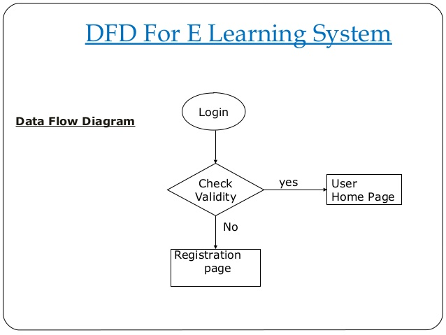

**USE CASE DIAGRAM:-** 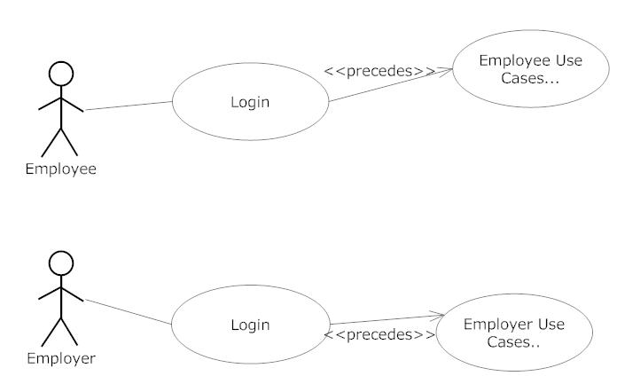

**ACTIVITY DIAGRAM:-**

**E-Learning Resource Locator

Activity Diagram: User Login

Tech Blazers

Page 20

 **

**6. CONTENT DEVELOPMENT:-**

**Content writing of subject content was undertaken to provide curriculum resources**

**on a Brainless learning model across the 10 main subject domains across the**

**partners (C ,C++ , JAVA , HTML , PYTHON , JAVASCRIPT , PHP , SQL , JQUERY ,CSS ).**

**The curriculum writing was coordinated by a Curriculum**

**Group made up of specialist staff from across the VGI College managed by a**

**Curriculum Project Manager. To achieve the deadlines the curriculum group also**

**secured freelance writers to support the joint endeavour. Central editing of co-created**

**content was undertaken by the all the developer of the VIHVESHWARYA GROUP OF**

**INSTITUTIONS College. Careful monitoring of the process was undertaken**

**by all the group members. All of the subject content was written in the pdf format for the**

**learning in the proper manner.**

**7. DESIGNELEARN NETWORK:-**

**Two potential business models for sustainability were identified at the**

**commencement of the Project:**

***Model 1:* Developing a business model for selling services for each of the**

**learning companies with a marketing strategy to produce income for a wage**

**premium.**

***Model 2:* Developing a business model for franchising the Academy to other**

**Colleges to ensure sustainability of funding for content refreshing, hosting and**

**ongoing curriculum development with a comprehensive dissemination**

**strategy across the sector.**

**8. CONCLUSIONS:-**

**This project has proved very successful in meeting its overall aims and objectives to**

**time and to schedule. It has created:**

**(A) A new qualification framework for e-Learning Students.**

**(B) An approved apprenticeship framework in Digital Learning Design.**

**(C) Shared Brainless learning content and resources to support the delivery of**

**the qualification.**

**(D) Dissemination to the wider sector for engagement in this initiative via a**

**good practice network.**